BonEDGE

Buyer

Training Guide

**Table of Contents**

**1.0 Key product terminology**

1. **How to create a Project**
   1. Creating a project by input in GUI
   2. Creating a project via Excel import
   3. Creating a project via API
2. **How to add/append to list of suppliers**
   1. Creating suppliers via Excel import
   2. Creating suppliers via API
3. **How to send an RFQ**
   1. Sending from within a project
   2. Sending from the RFQ tab
   3. Sending RFQs with price breaks
4. **How to receive bids back from suppliers**
5. **How to evaluate bids from different suppliers**

**Login:**

1. Login with your email and password

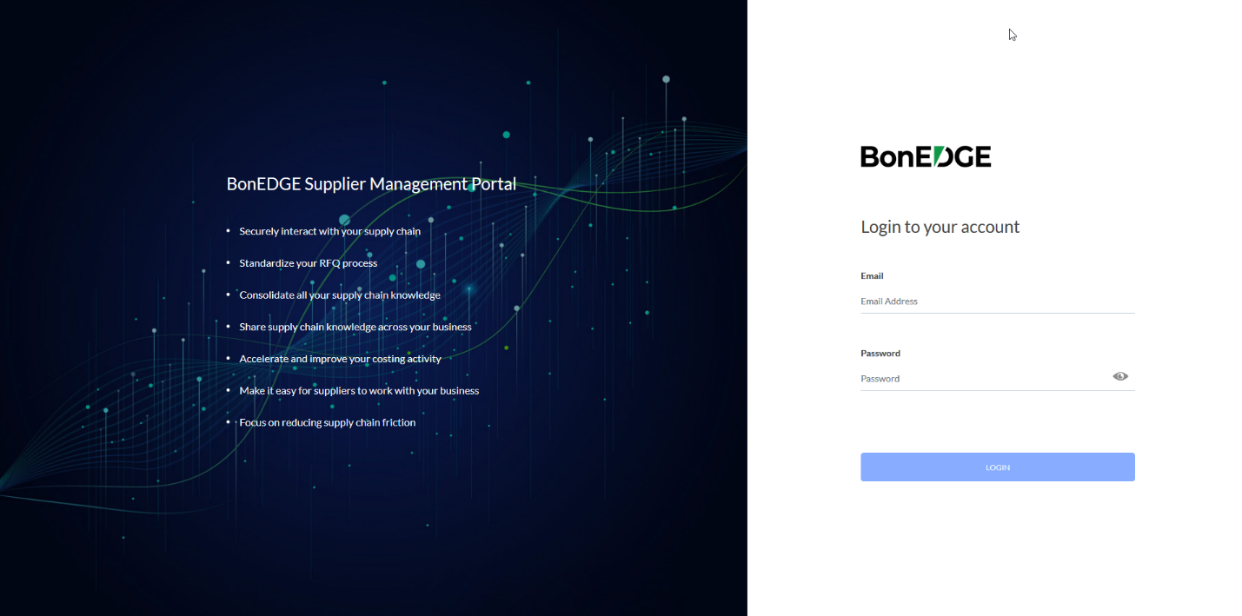

**Dashboard:**

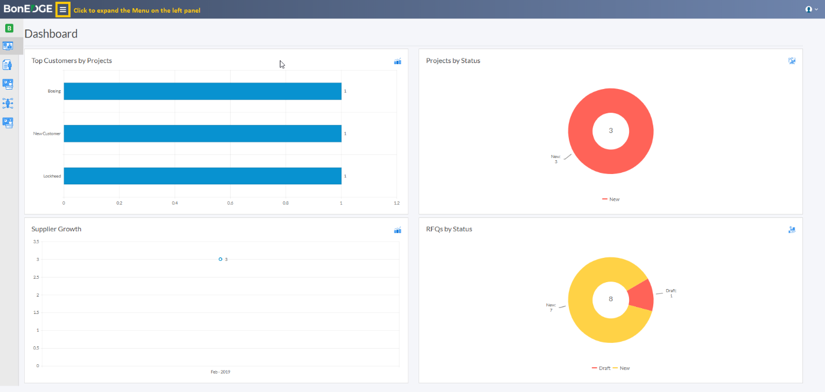

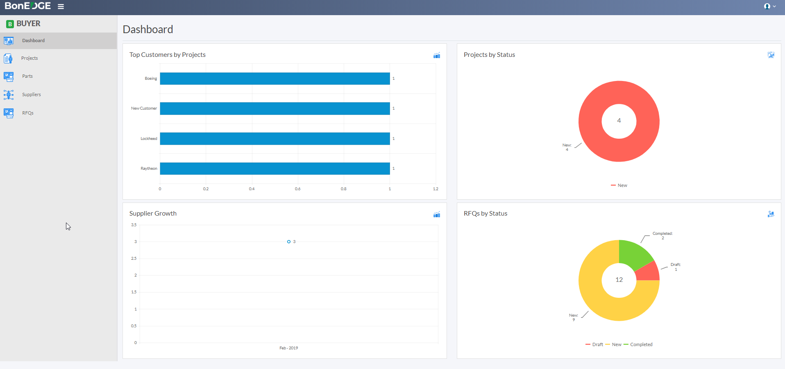

**Projects:**

**Parts:**

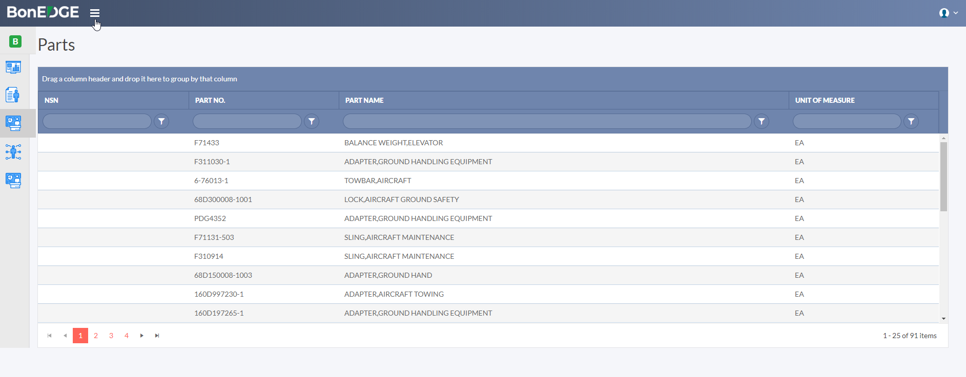

**Suppliers:**

